Enterprise Network ITNW 2350

Lab 3.1.1b

GYIMP

Jacob Calvert, Timothy Zellers, Regan Stubbs, James Baker, Faustino Gonzolez

Criteria #1a: File System structure / layout showing a) personal / home directories & b) dept. share directories. Note: Company departments: Broadcast, Public Relations, Publishing, social media, Animation, Video Production, Web Hosting, HR and Finance.

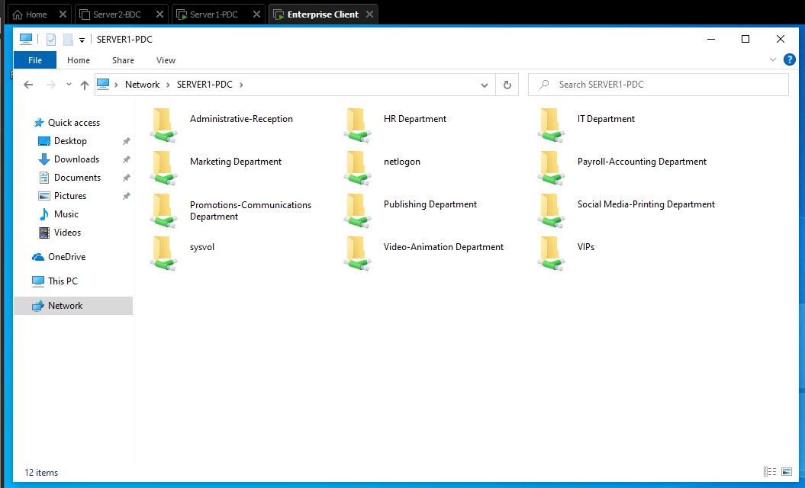

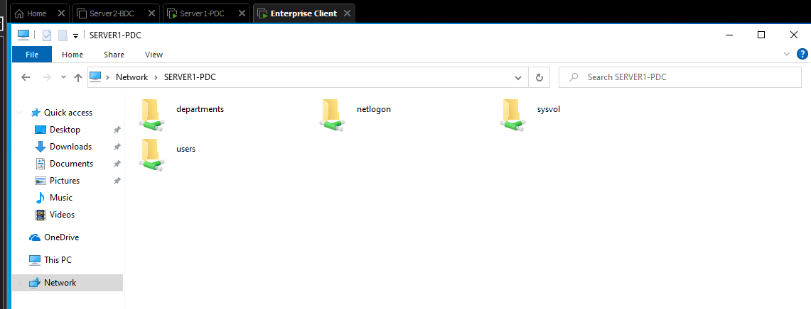

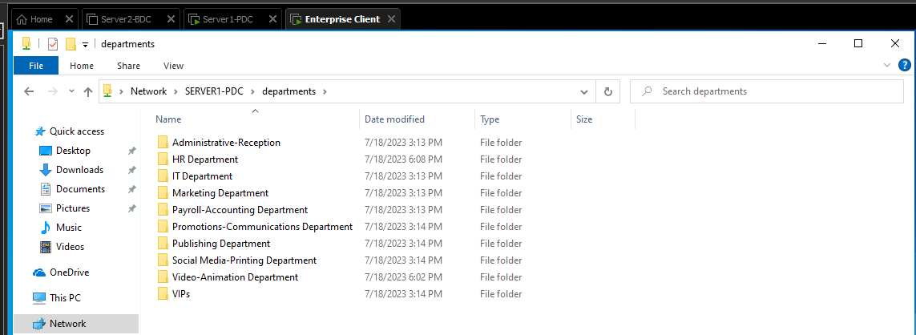

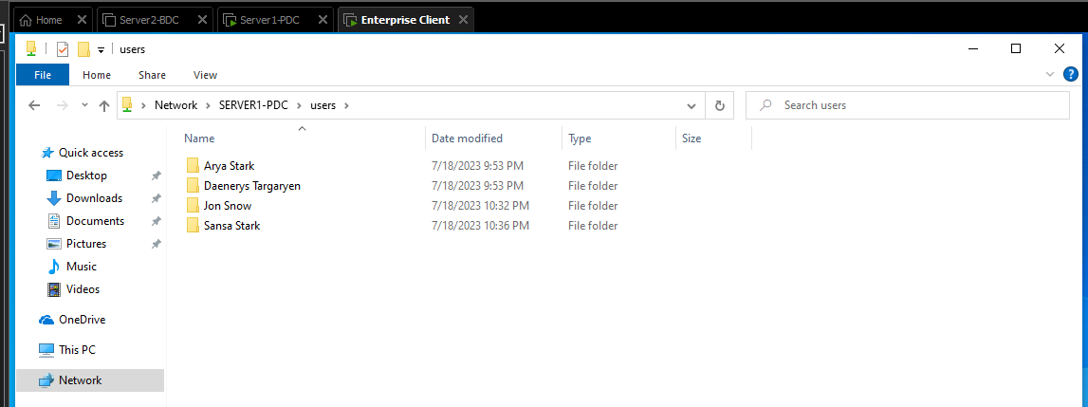

Criteria #1b: File System ACL – home directories: Provide evidence at least 2 employees NTFS “effective access” permissions granted - user home / personal directory showing the correct employee has Full Control and another employee is denied “effective access” permissions to the same employee’s personal directory.

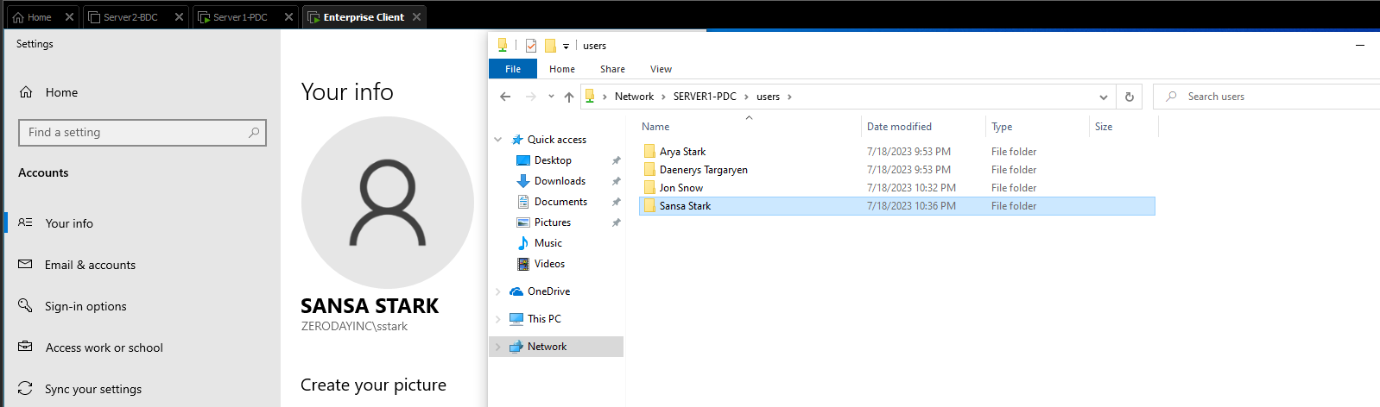

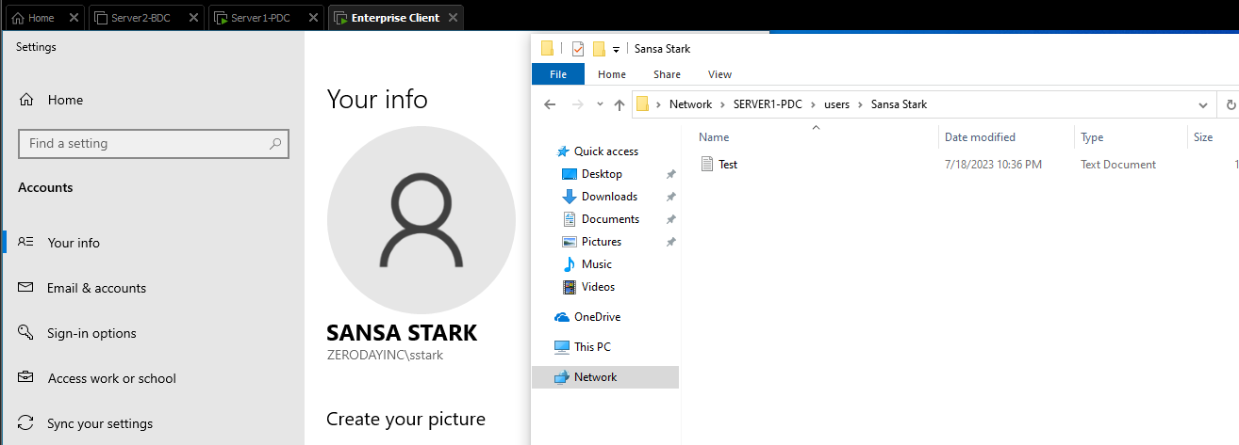

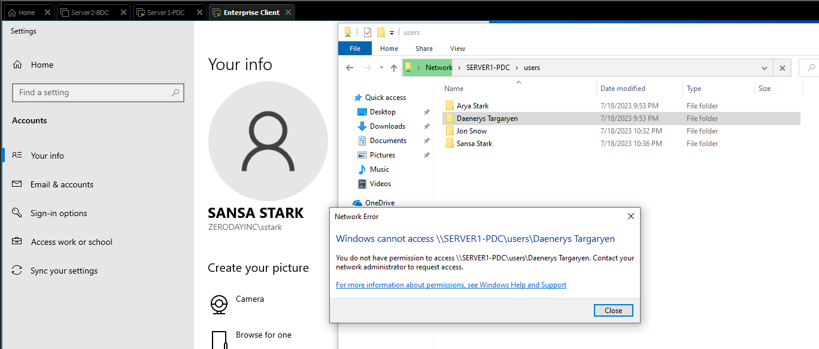

Criteria #1c: File System ACL - dept. shares: Provide evidence to at least two different dept. share folders a) “effective access “permissions granted & b) at least 1 denied access to: individual dept. Common shared with ACL evidence.

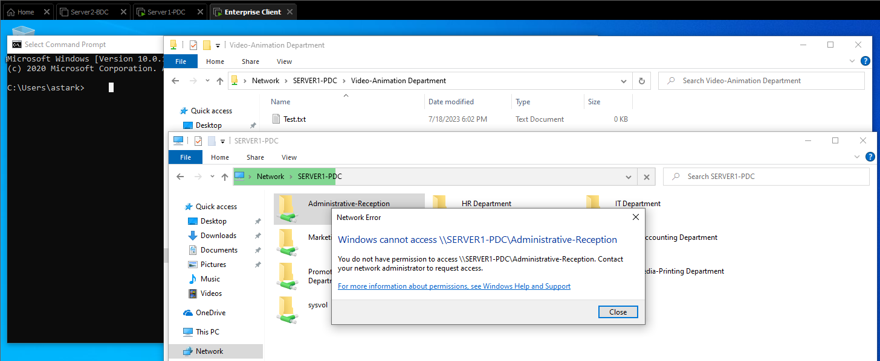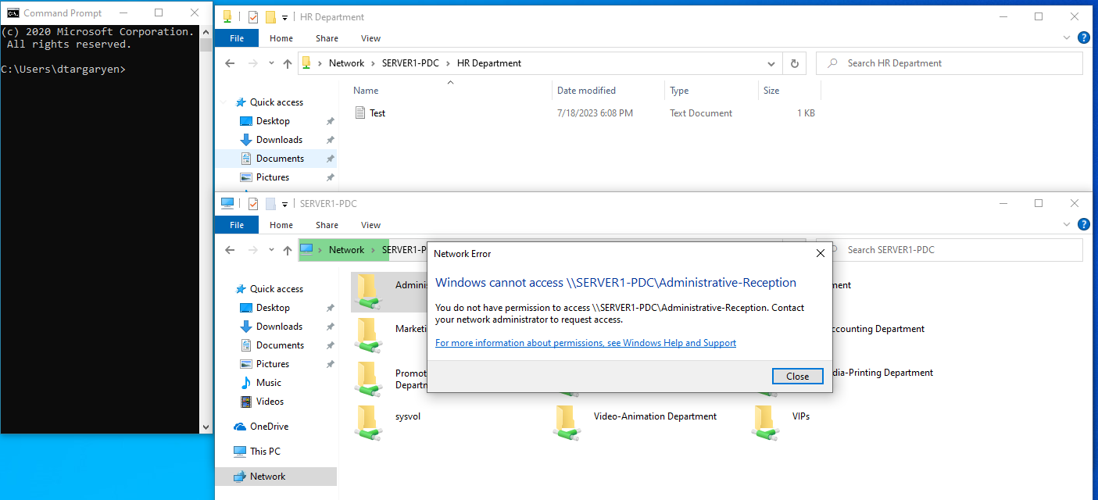

Criteria #2a: Printer Server Evidence created and configured

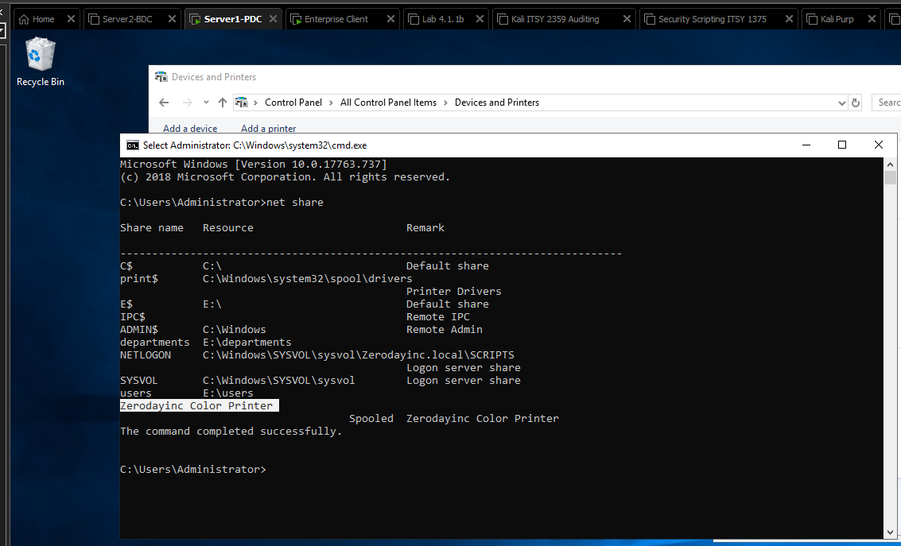

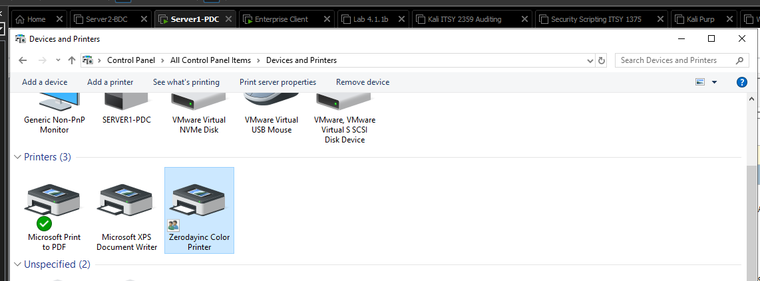

Criteria #2b: Network Printer Evidence created and ready for deployed with GPOs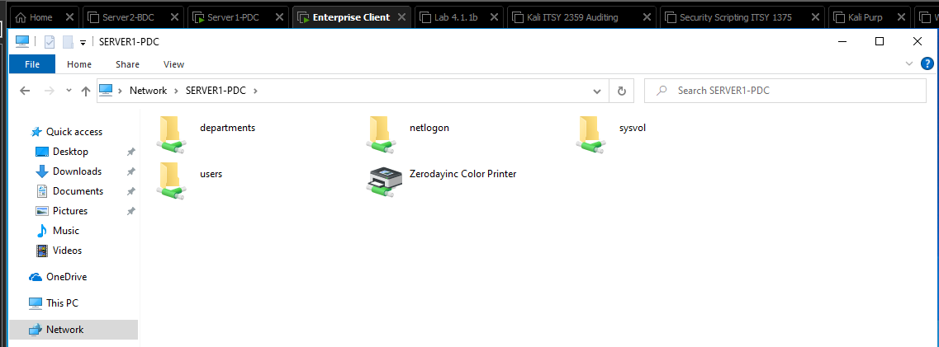

Criteria #3 Evidence NOS have applied critical updates

